**ASSIGNMENT 27.2**

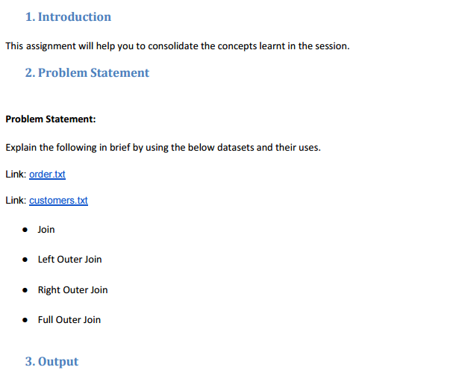

**First we create the two tables and load the data:**

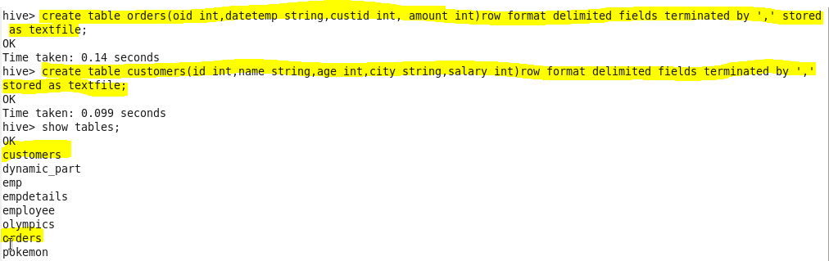

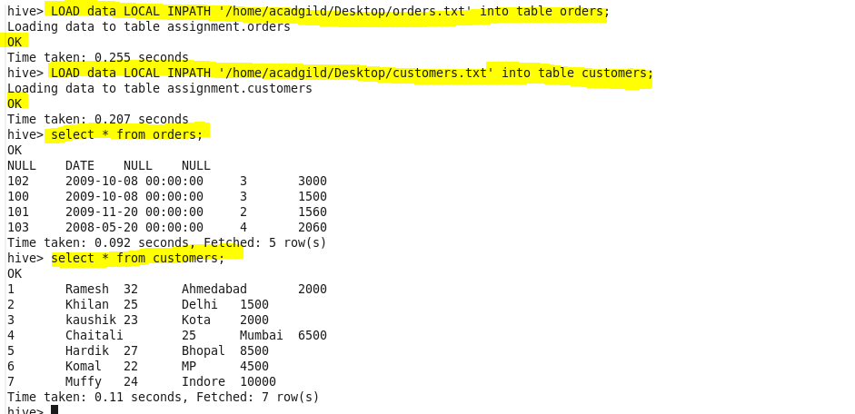

● **JOIN**

JOIN clause is used to combine and retrieve the records from multiple tables. A JOIN condition is to be raised using the primary keys and foreign keys of the tables.

Here, joining ‘order_data’ and ‘customer_data’ tables using JOIN and ‘select’ is used to display the output.



Output:

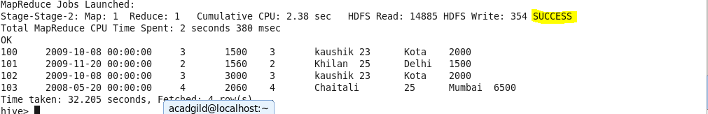

Only the matching records are displayed.

● **Left Outer Join**

A LEFT JOIN or LEFT OUTER JOIN returns all the values from the left table even if no matching value in the second table, plus the matched values from the right table, or NULL in case of no matching JOIN predicate.

Below is the query using left outer join.

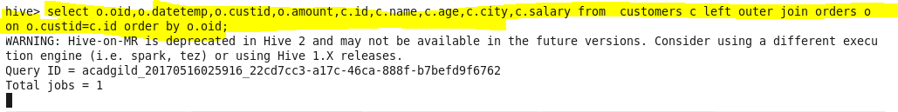

Output:

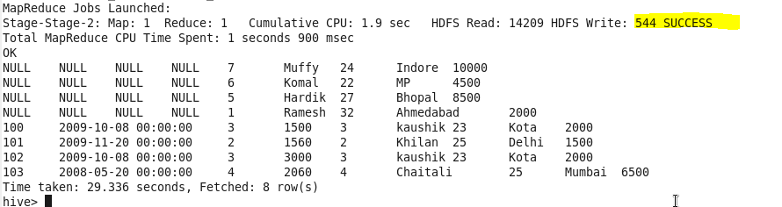

All the data from the left table gets joined with the matching data in the right table and is displayed

**● Right Outer Join**

A RIGHT JOIN returns all the values from the right table, plus the matched values from the left table, or NULL in case of no matching join predicate.

Below is the query using right outer join.

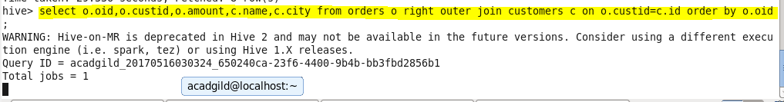

Output:

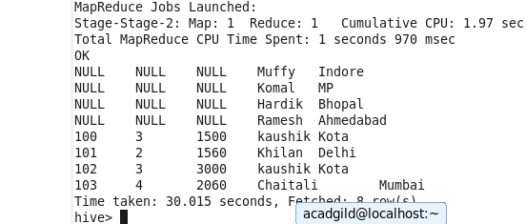

All the data from the right table and matching data from the left table is displayed.

**● Full Outer Join**

The FULL OUTER JOIN in HIVEQL combines the records of both the left and the right outer tables that fulfil the JOIN condition. The joined table contains either all the records from both the tables, or fills in NULL values for missing matches on either side.

Below is the query using full outer join with output.

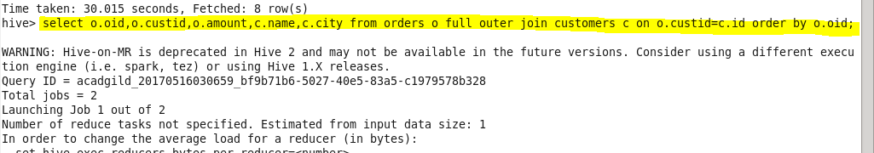

Output:

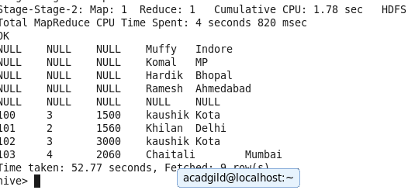

Full outer join displays matching as well as unmatched data from both the tables.